Modulo3 buckets dynamo
Crear bockuet

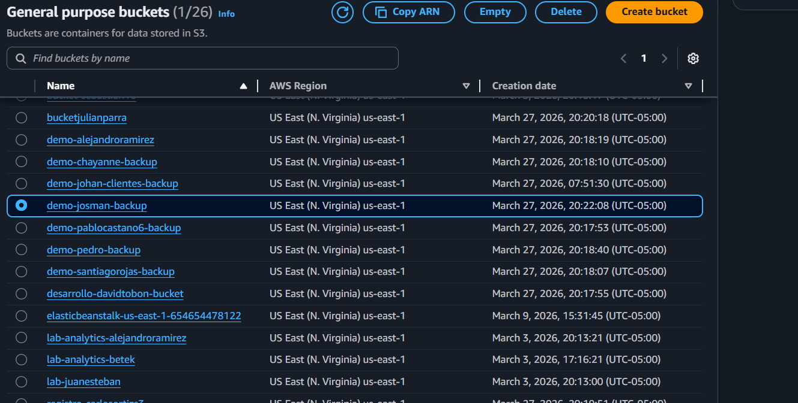
Crear tabla
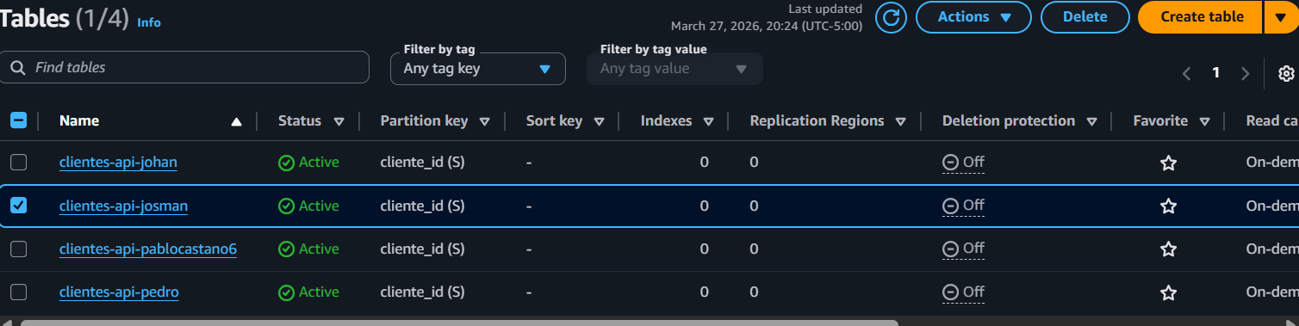
Crear políticas
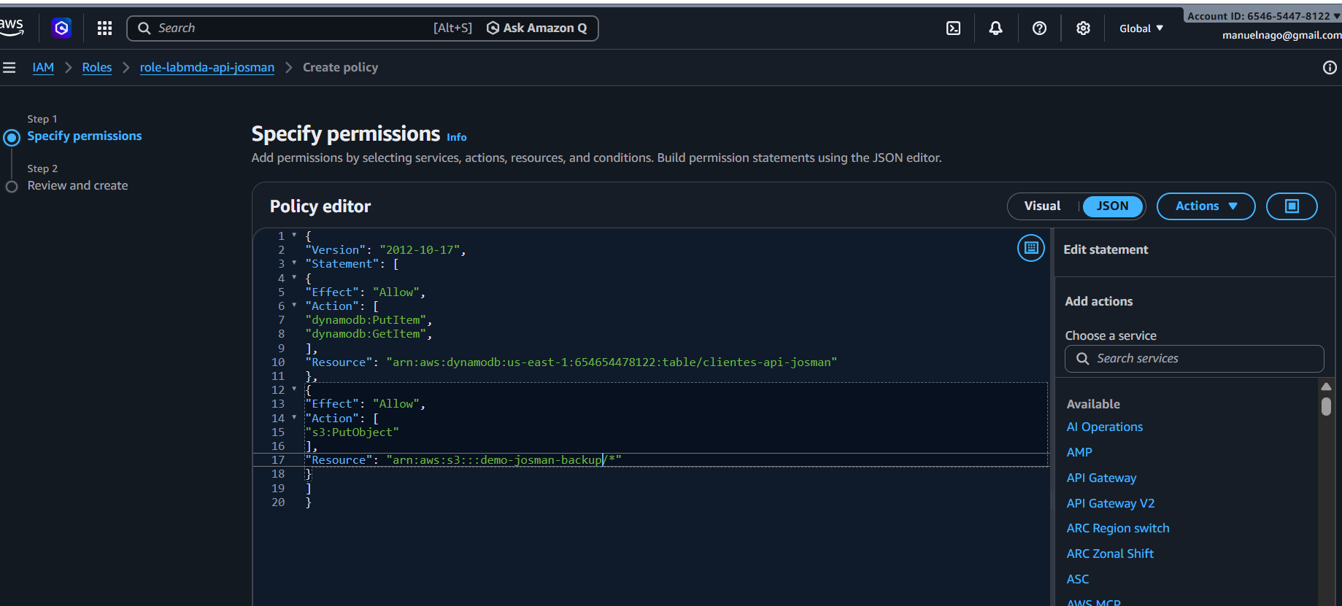
Crear variable de entorno
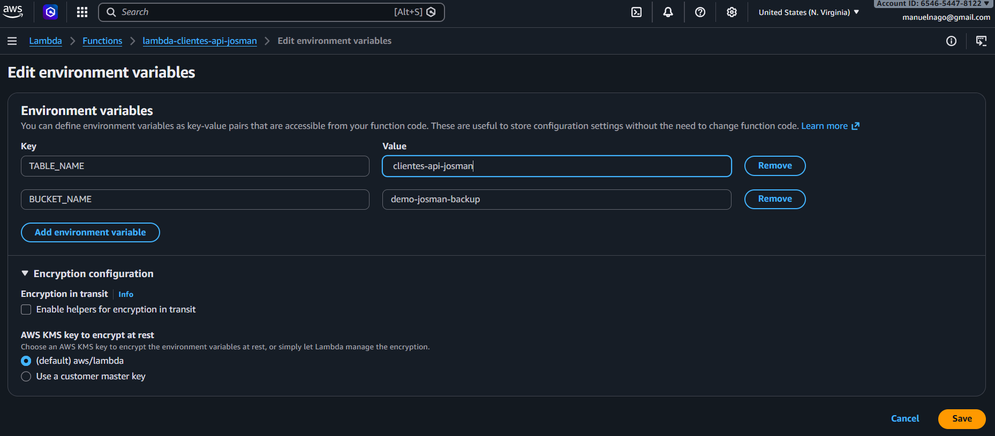
Configuración api
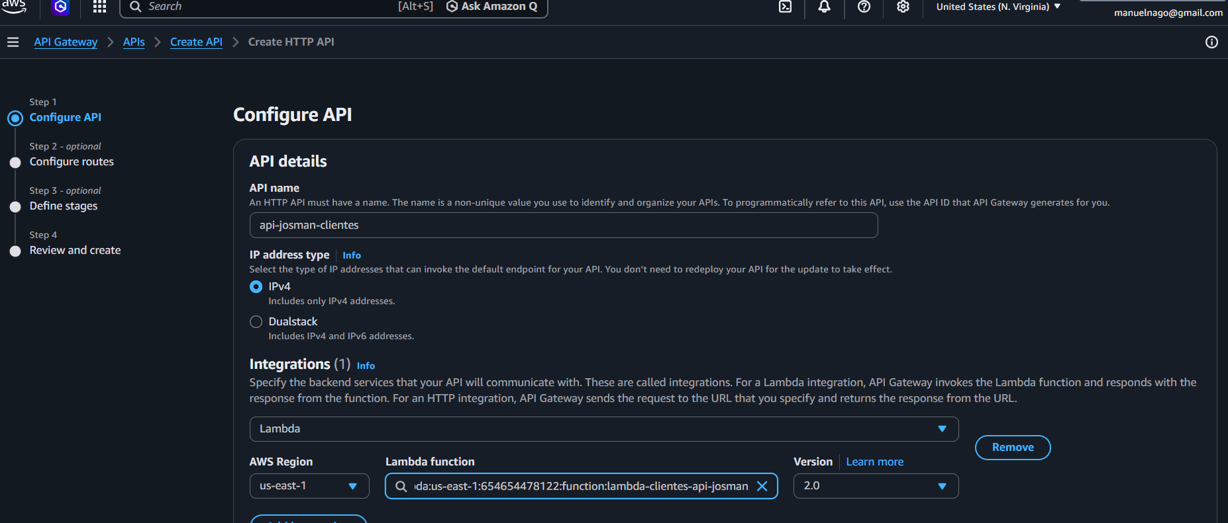
Configurar tutas
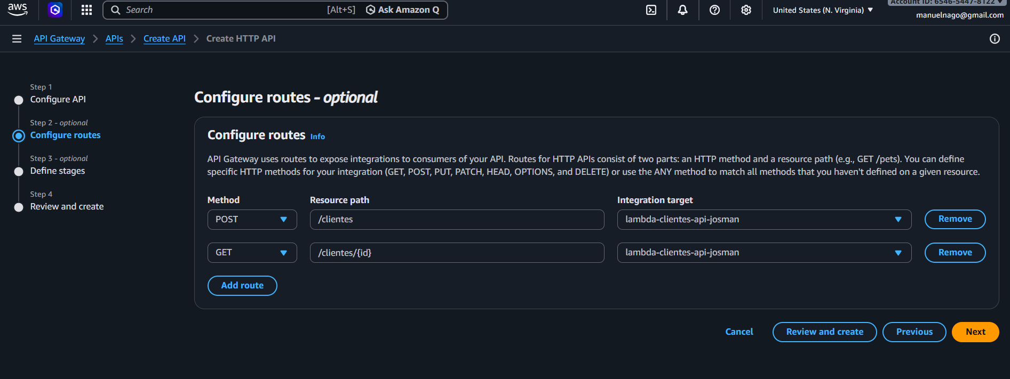
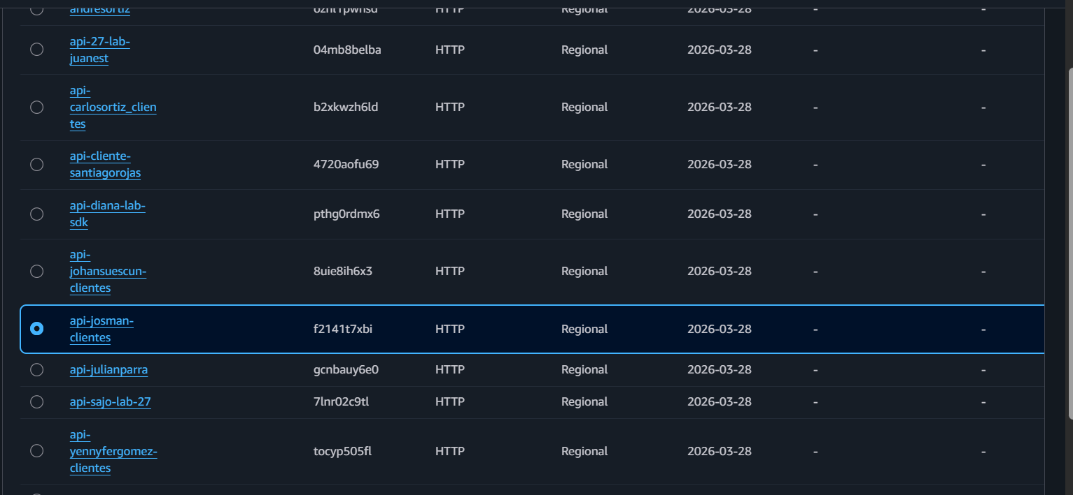

curl -X POST " https://f2141t7xbi.execute-api.us-east-1.amazonaws.com/clientes" -H "Content-Type: application/json" -d '{
"nombre": "Johan",
"correo": "johan@democurl.com",
"ciudad": "Bogotá"
}'

curl -X POST "https://f2141t7xbi.execute-api.us-east-1.amazonaws.com" -H "Content-Type: application/json" -d '{
"nombre": "Johan",
"correo": "johan@democurl.com",
"ciudad": "Bogotá"
}'

$body = @{
nombre = "Jose Manuel Cruz"
correo = "manuelnago@gmail.com"
ciudad = "Tunja"
} | ConvertTo-Json

Invoke-RestMethod -Uri "https://f2141t7xbi.execute-api.us-east-1.amazonaws.com/cliente" -Method Post -Body $body -ContentType "application/json"

